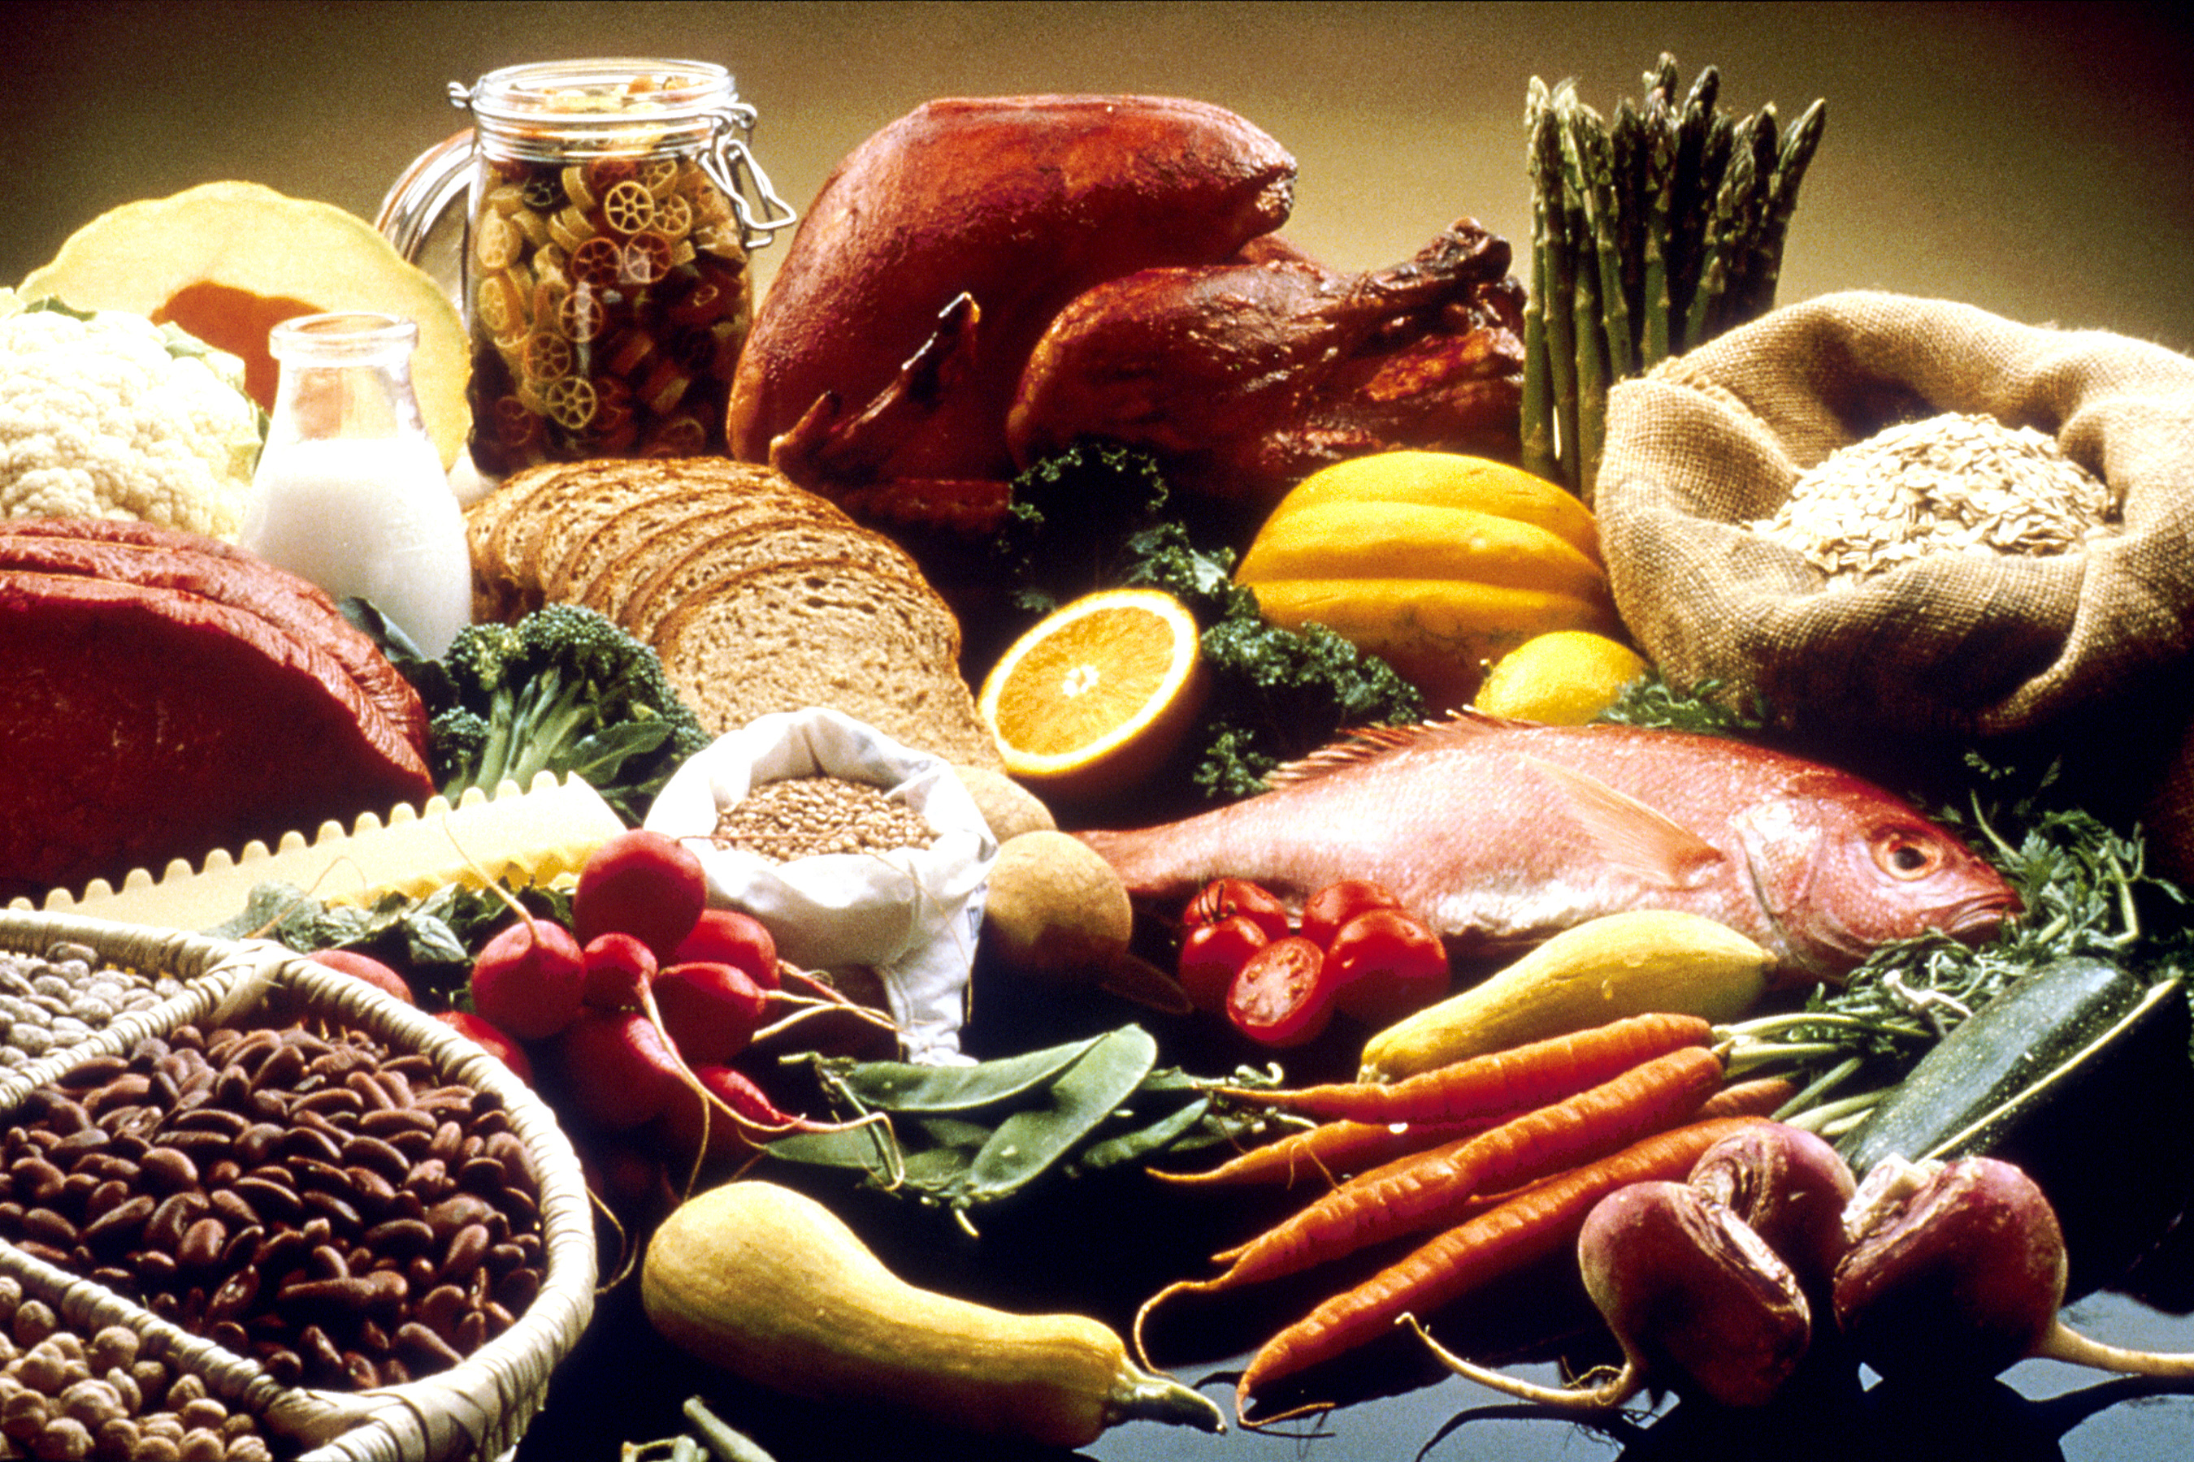

Good Brain Food

Avocados Bananas Beef, lean Broccoli

Brown rice Rockmelon Cheese Chicken

Eggs Flaxseed oil Milk Oatmeal

Oranges Peanut Butter Peas Potatoes

Salmon Soybeans Spinach Tuna

Turkey Wheatgerm Yoghurt