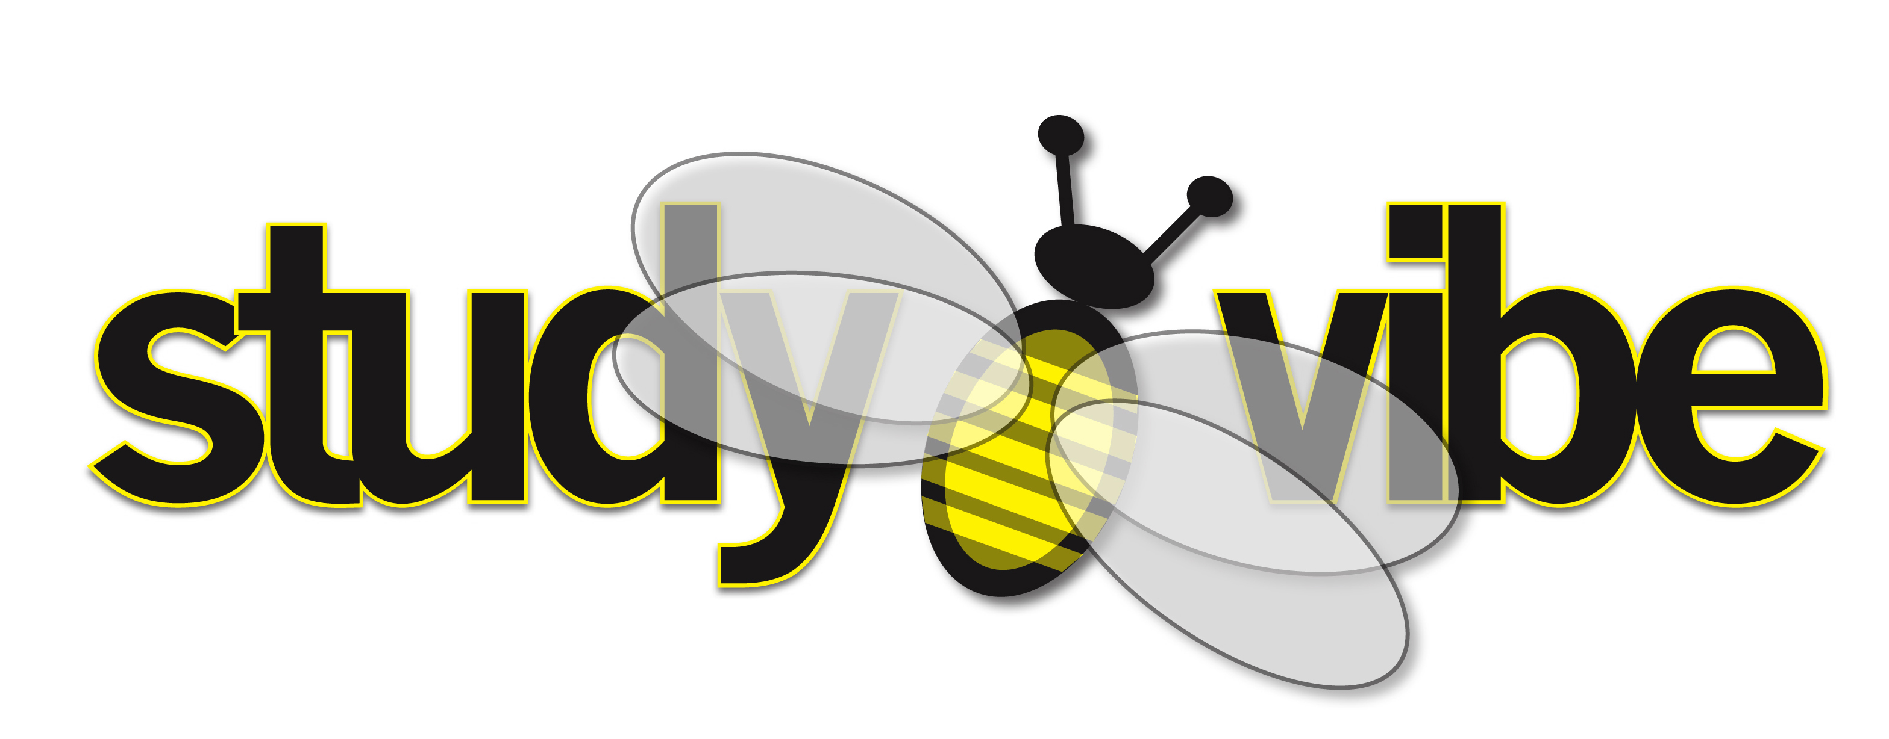
Becoming an Achiever
Worksheet One

Rate yourself in these areas

S W Tick S – STRENGTH W - WEAKNESS

_____ _____ I have confidence in myself

_____ _____ I am a risk-taker

_____ _____ I am willing to work to make changes in myself

_____ _____ I take responsibility for my problems and don’t blame
other people

_____ _____ I try to think outside creatively about things

_____ _____ I try to always look at things in a positive way

_____ _____ I am flexible and can see more than one possible
solution when solving a problem

_____ _____ I have an area of special interest – something I am passionate about

_____ _____ I practice discipline and self-control

_____ _____ I get excited when I try new things

_____ _____ When things go wrong I don’t get angry with myself

_____ _____ When things go wrong I try not to think “poor me”

_____ _____ I try to hang around with people who are positive

_____ _____ I am a hard worker and always try to do my best

_____ _____ I am clear about the things I want to do

Congratulations on your strengths!!!

The weaknesses you have ticked will be the basis for some of the activities we do as part of the Studyvibe Community. Remember these are NOT FAILURES but CHALLENGES to give you a focus for improvement. Why not join us so you can meet the challenge of turning these weaknesses into strengths.

